MODULE 2

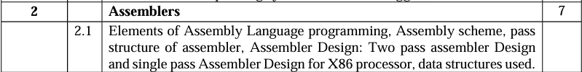

Nov 2023

Q. Explain in brief “forward reference problem”. Explain how it handles forward reference problem in single pass assembler (5M)

Q. Draw the flowchart of pass1 assembler and explain its working with the databases (10M)

Q. State and explain the types of assembly language statements with examples(10M)

May 2023

Q. Discuss with example “forward reference”(5M)

Q. State and explain with examples , different types of statements used in assemblers with respect to system programming

Nov 2022

Q. Draw the flowchart of pass1 of two pass assembler with suitable example(10M)

Q. Explain with flowchart design of two pass assembler(10M)

May 2022

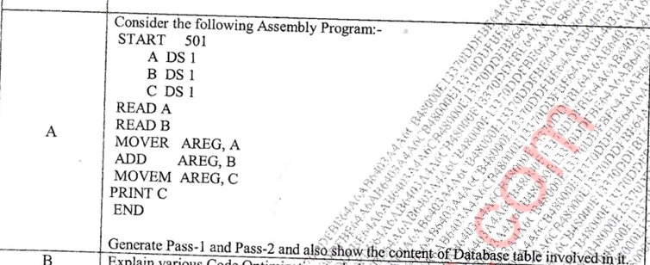

Q. Draw a neat flowchart of pass-1 of two pass assembler design(5M)

May 2019

Q. Explain forward reference problem and how it is handled in assembler design. (5M)

Q. With reference to assembler explain the following table with example

1. MOT 2. POT 3. ST 4. BT (10M)

Q. With reference to assembler explain the following table with example

1. MOT 2. POT 3. ST 4. BT 5.LT (10M)

Q. Draw flowchart of pass-1 of two pass assembler design and explain in detail (10M)

DEC 2019

Q. Enlist the different types of errors that are handled by Pass 1 and Pass 2 of assembler (5M)

Pass 1 and Pass 2 of an assembler perform different tasks in the assembly process and handle different types of errors:

\*\*Pass 1:\*\*

1. \*\*Syntax Errors\*\*: Pass 1 identifies syntax errors in the assembly language source code. These errors occur when the source code does not conform to the syntax rules of the assembly language. Examples include missing or misplaced punctuation, incorrect operand syntax, or unrecognized directives.

2. \*\*Label Errors\*\*: Pass 1 checks for label-related errors, such as duplicate labels or invalid label names. Duplicate labels occur when multiple symbols have the same name within the same scope, causing ambiguity in the symbol table. Invalid label names violate naming conventions or conflict with reserved keywords.

3. \*\*Address Calculation Errors\*\*: Pass 1 calculates the addresses of labels and symbols encountered in the source code. It ensures that each symbol has a unique address and computes the correct memory location for each instruction or data declaration. Address calculation errors may occur due to incorrect or inconsistent addressing modes, resulting in invalid memory references.

4. \*\*Directive Errors\*\*: Pass 1 verifies the correctness of assembler directives and processes them accordingly. Directive errors occur when directives are used incorrectly or with invalid arguments. Examples include errors in defining constants, allocating memory space, or specifying data formats.

5. \*\*Symbol Table Errors\*\*: Pass 1 builds and maintains the symbol table, which maps symbols to their corresponding addresses or values. Symbol table errors may occur due to symbol redefinition, conflicting symbol declarations, or incomplete symbol information.

\*\*Pass 2:\*\*

1. \*\*Referencing Errors\*\*: Pass 2 resolves symbolic references and generates the final machine code by replacing symbolic addresses with their corresponding numeric values. Referencing errors occur when a symbol is referenced but not defined or when the referenced symbol cannot be resolved due to scope or visibility issues.

2. \*\*Opcode Errors\*\*: Pass 2 translates assembly instructions into machine code instructions based on opcode mappings and addressing modes. Opcode errors occur when an assembly instruction uses an invalid or unsupported opcode, or when the specified addressing mode is incompatible with the instruction.

3. \*\*Operand Errors\*\*: Pass 2 verifies the correctness of instruction operands and ensures that they match the expected data types and addressing modes. Operand errors may occur when the number or type of operands provided for an instruction does not match its definition, or when the operands exceed the allowable range or size.

4. \*\*Expression Errors\*\*: Pass 2 evaluates and resolves arithmetic expressions encountered in the assembly code, such as address calculations or constant expressions. Expression errors occur when an expression contains syntax or semantic errors, or when it cannot be evaluated due to unresolved symbols or invalid operators.

5. \*\*Output Errors\*\*: Pass 2 generates the final object code or listing file containing the assembled program. Output errors may occur during file writing or formatting, such as disk space errors, file system permissions, or file format mismatches.

Overall, Pass 1 primarily focuses on lexical and syntactic analysis, symbol resolution, and address calculation, while Pass 2 handles semantic analysis, code generation, and error detection specific to the assembly language instructions and machine architecture. Q. Explain with flowchart design of two pass assembler (10M)

2018

Q. Draw flowchart and explain with databases the working of pass 2 of assembler(10M)

